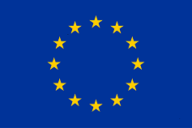
Internal document
TRAINING on the European Territorial Cooperation Programmes - Focus on Health Opportunities
This presentation is part of the action “NFP4Health”
which has received funding from the European Union’s Health
Programme (20144-2020) under grant agreement No 101035965.
NFP4Healt
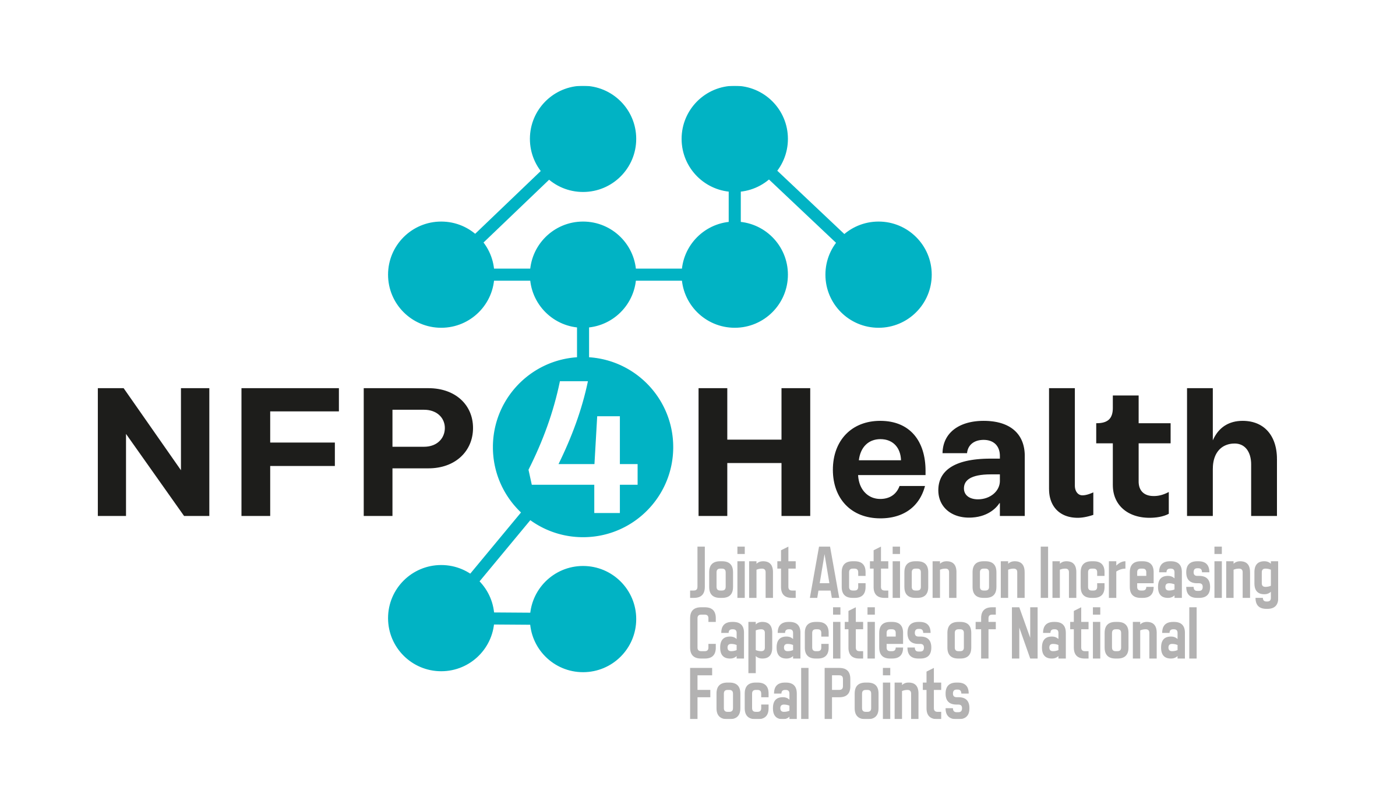

D6.2 Training Minute

Deliverable lead partner |  | PROMIS
Contributing partner(s) |  | ACRONYM(S)
Work Package |  | WP6
Deliverable type |  | Internal Report
Contractual delivery date |  | 19.05.2023
Actual delivery date |  | 19.05.2023
Dissemination level |  | Confidential
Version |  | 1.00

ABSTRACT
The minute presents a summary of the contents elaborated during the training on the European Territorial Cooperation Programmes with a focus on health opportunities

STATEMENT OF ORIGINALITY
This deliverable contains original unpublished work except where clearly indicated otherwise. Acknowledgement of previously published material and of the work of others has been made through appropriate citation, quotation or both.

DISCLAIMER
The content of this deliverable represents the views of the author only and is their sole responsibility; it cannot be considered to reflect the views of the European Commission and/or HaDEA or any other body of the European Union. The European Commission and the Agency do not accept any responsibility for use that may be made of the information it contains.

In the framework of the JA NFP4Health WP6 – Capacity building for National Focal Points an on-line training has been organized on 16 may 2023, with the aim to present the opportunities in the framework of the European Territorial Cooperation Programmes. The event has been structured as following: an introduction on the ETC (i.e. purposes, tools, and the difference between past and new programming periods); a focus on good practices and funded projects; and a final open discussion on synergies and complementarities between funds.

In the first presentation, an introductory overview of the ETC origin was offered. Starting from spontaneous cooperation between public entities in 1950 and passing through the first Euroregion established between Germany and The Netherlands in 1958 and a number of Euroregions developed in the 60s and 70s mainly in Central and Northern Europe, the Association of European Border Regions was established in 1971 and in 1980 there was the European Framework Convention on the Cross-border Cooperation of Local Communities or Authorities, offering a shared legal framework for cross-border cooperation between sub-state (regional and local) authorities. In the second programming period, from 1994 and 1999 the sea was considered border. The highest peak of investments was recorded in the fifth programming period, which reached 10,1 BN€.
New items introduced in the last European Territorial Cooperation (ETC) Programming Period 2021-2027 have been highlighted:
- transition from 11 thematic objectives (in the previous programming periods) to 5 priorities focused on key objectives, including “social and inclusive Europe” which is related to health care.
- simplification introduced, with regards to lighter and more frequent reporting, lighter controls for programmes, fast delivery….
- flexible programming adjusted to new challenges and emerging needs
- reinforced visibility and communication provisions (required)
Finally, the four declination of cooperation (transnational, cross-border, interregional and outermost cooperation) have been clarified.
The second intervention provided a presentation of B4B Bridges for birth project, which is a funded and completed cross-border cooperation initiative aimed at strengthen institutional cooperation between Slovakia and Austria in the area of neonatal emergencies, specifically:
- creating framework conditions for cross-border patient care in the field of neonatalogy, improving access to healthcare facilities for people living in borders region, enabling cooperation for the transport of neonatal emergencies, elaborating necessary legislative changes and future rescue contract, as well as working on practical clinical cooperation guideline and purchase of equipment.

The last presentation provided an analysis of the capacity building, ICT tool use, awareness raising actions that Interreg has financed during 2014-2020 with reference to the 4 healthcare related thematic clusters: healthcare provision, social inclusion, innovation, training and networking. Two examples were presented for each cluster:
- healthcare provision (B4B - bridges for birth and NUMA- nuevo modelo asistencial)
- social inclusion (better access to specialised healthcare services for ederly population and babies across borders)
- innovation (MEDIWARN- virtual biosensor for medical warning precursors and BONE- Biofabrication of orthopaedics in new era)
- training and networking (ZORO – Zorgroute Arbeidsmarkt and TELE.doc – Innovative trauma and injury management practices)
With a focus on healthcare clusters, it has been highlighted that the actions were concentrated in northern and central Europe, with negligible investments in the South of Europe.
Finally, to address synergies and complementarities between EU4Health and ETC a mention was made about tools available online:
- Keep.eu which serves all professional audiences in need of aggregated data regarding projects and beneficiaries of European Union cross-border, transnational and interregional cooperation programmes among the member States, and between member States and neighbouring or pre-accession countries. The Interact Programme built this database and maintains it, as part of its mission, with the remaining Interreg programmes, and with the support of the European Commission. The database covers the 2000-2006, 2007-2013 and 2014-2020 periods, and is currently incorporating data on the 2021-2027 period.
- www.interreg.eu which collects resources and calls for projects.

